Fall-18 CSE221-3 Quiz-2 Total mark: 20

1. The graph represents a city with the vertices representation areas and the weights as the distance in kms. You start your journey from A. Find a short cut to D. Name the algorithm and derive the time complexity. [5 + 1 + 4 = 10].

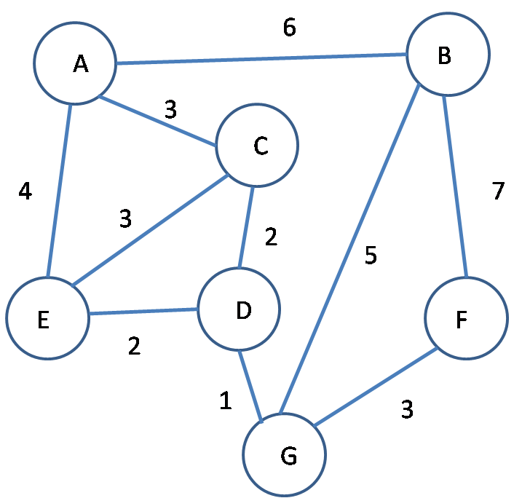

1. **Priority Queue** is an Abstract Data Structure where elements with higher priority get service first no matter when they arrive. For example you are waiting in a queue to see a doctor but an emergency patient turns in and he gets service first.

Explain with a small diagram how Priority Queue can be implemented using a Heap Tree. Why is heap used rather than a sort? [6 + 4 = 10]